# EXPERIMENT NO: -8

**Aim: Write test cases for white box testing. Explanation:**

What is a Test Case?

A TEST CASE is a set of actions executed to verify a particular feature or functionality of your software application. A Test Case contains test steps, test data, precondition, postcondition developed for specific test scenario to verify any requirement. The test case includes specific variables or conditions, using which a testing engineer can compare expected and actual results to determine whether a software product is functioning as per the requirements of the customer.

The format of Standard Test Cases

|  |  |  |  |  |  |  |
| --- | --- | --- | --- | --- | --- | --- |
| Below is a format of a standard login Test cases example. | | | | | | |
| Test Case ID | Test Scenario | Test Steps | Test Data | Expected Results | Actual Results | Pass/Fail |
| TU01 | Check the data and search icon | 1. Open html file 2. Search city name | City,state ,country name | Display the content of frontpage | As Expecte d | Pass |
| TU02 | Search for any city | 1. Search in search box 2. Then click enter 3. It will weather information | Weather of any City | Display the weather information | As Expecte d | Pass |

This entire table may be created in Word, Excel or any other Test management tool. That’s all to Test Case Design

While drafting a test case to include the following information

* The description of what requirement is being tested
* The explanation of how the system will be tested
* The test setup like a version of an application under test, software, data files, operating system, hardware, security access, physical or logical date, time of day, prerequisites such as other tests and any other setup information pertinent to the requirements being tested ● Inputs and outputs or actions and expected results
* Any proofs or attachments
* Use active case language
* Test Case should not be more than 15 steps
* An automated test script is commented with inputs, purpose and expected results
* The setup offers an alternative to pre-requisite tests
* With other tests, it should be an incorrect business scenario order

# White Box Testing

White Box Testing is software testing technique in which internal structure, design and coding of software are tested to verify flow of input-output and to improve design, usability and security. In white box testing, code is visible to testers so it is also called Clear box testing, Open box testing, Transparent box testing, Code-based testing and Glass box testing.

It is one of two parts of the Box Testing approach to software testing. Its counterpart, Blackbox testing, involves testing from an external or end-user type perspective. On the other hand, White box testing in software engineering is based on the inner workings of an application and revolves around internal testing.

What do you verify in White Box Testing?

White box testing involves the testing of the software code for the following:

* Internal security holes
* Broken or poorly structured paths in the coding processes
* The flow of specific inputs through the code
* Expected output
* The functionality of conditional loops
* Testing of each statement, object, and function on an individual basis

How do you perform White Box Testing?

# STEP 1) UNDERSTAND THE SOURCE CODE Step 2) CREATE TEST CASES AND EXECUTE

**Whitebox Testing Example Consider the following piece of code**

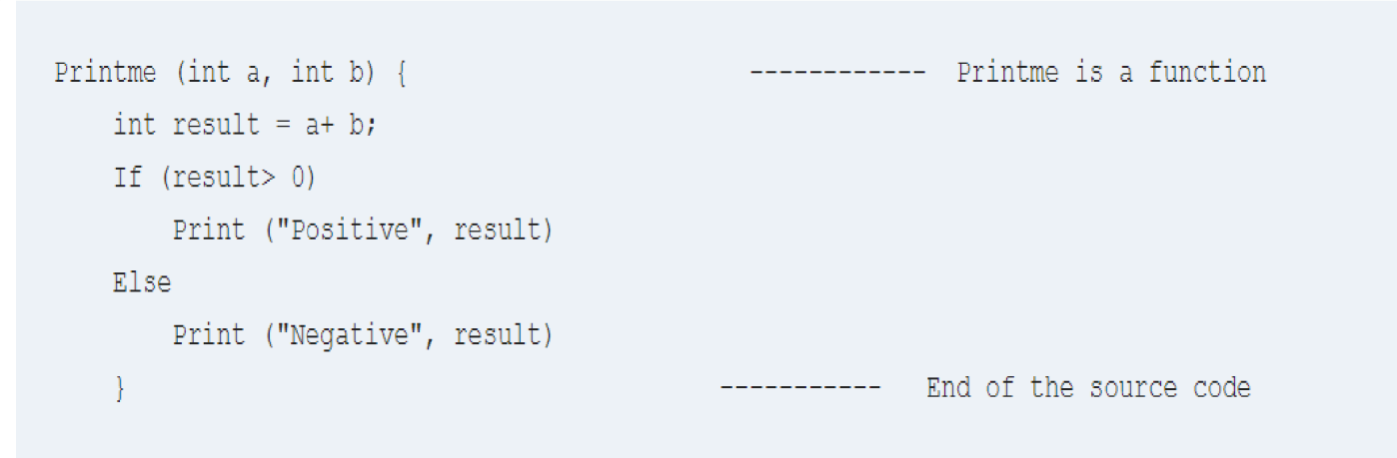

The goal of WhiteBox testing in software engineering is to verify all the decision branches, loops, statements in the code.

To exercise the statements in the above white box testing example, WhiteBox test cases would be

# A = 1, B = 1

* **A = -1, B = -3**

**Test Cases for Weather Application:**

|  |  |  |  |  |  |  |
| --- | --- | --- | --- | --- | --- | --- |
| **c** | **Test Scenario** | **Test Steps** | **Test Data** | **Expected**  **Results** | **Actual**  **Results** | **Pass/Fail** |
| 1 | Create Webpage to store Data | 1.Write the code into the editor 2.Save the file with .html extension. | Test the above code for creating front page | Display the Webpage content. | As expected | Pass |
| 2 | Apply styles to the webpage | 1.Write the code into the editor 2.Save the file with .css extension. | Test the above code for styels | Show the styles to the webpage | As expected | Pass |
| 3 | Add react icons | 1. Write the code into the editor 2. Save the file with .html extension. | Test the search bar icon | Show the content which user write. | As expected | Pass |
| 4 | Add behaviour to webpage | 1. Write the code into the editor 2. Save the file with .js extension. | Test the above code. | Show the correct information related weather | As expected | Pass |